# Creating Virtual Machines (VM1 & VM2)

For VM 1

Step 1: Open Oracle VM VirtualBox

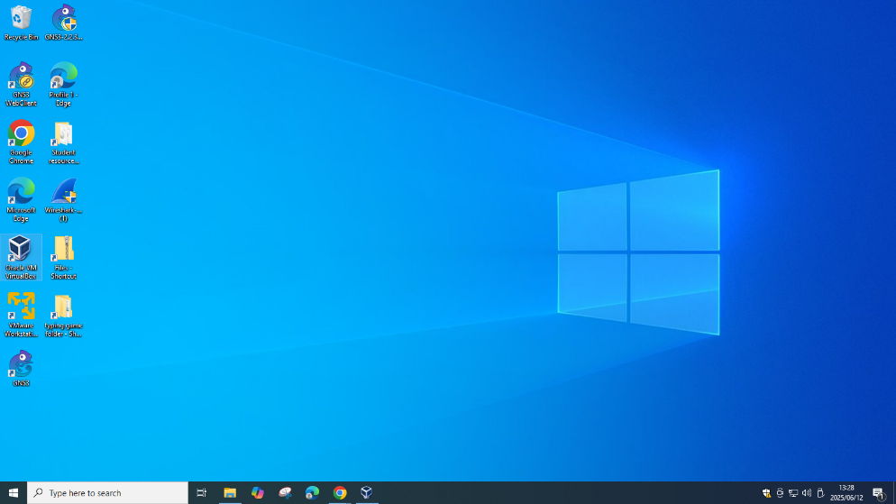

Step 2: Click on New, Name OFFICE PC-1, Type Microsoft Windows, Version Windows 8.1(32 or 64 bit based on your device)

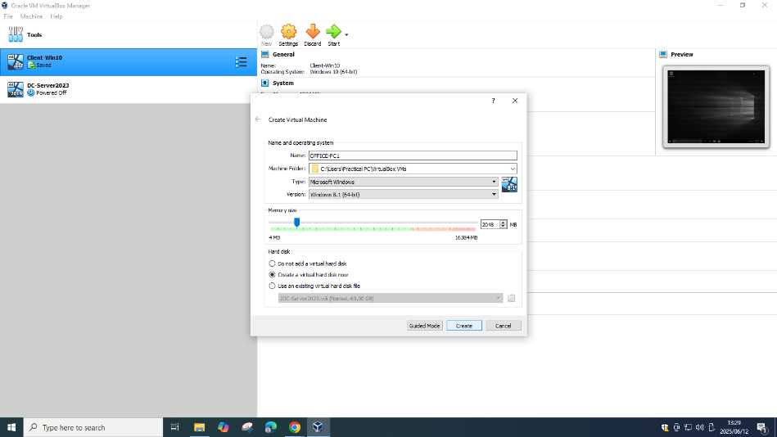

Step 3: Create VHD, click Create

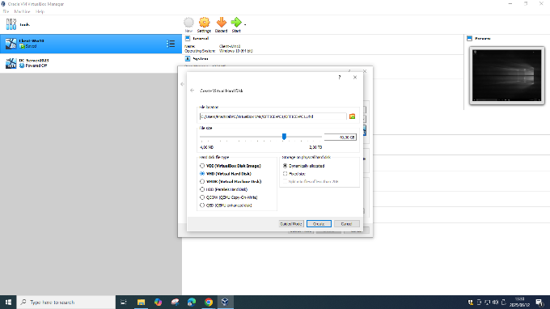

Step 4: Go to the Virtual machines settings, click on Storage, Click the Empty CD/DVD

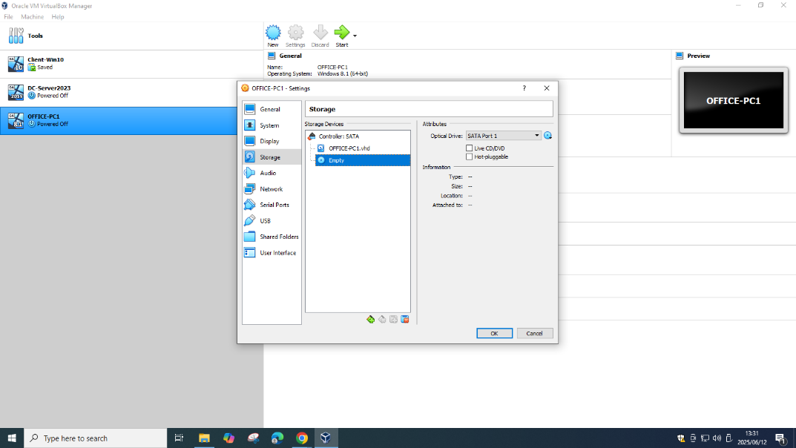

Step 5: Click the dropdown box on the right and Choose a disk file

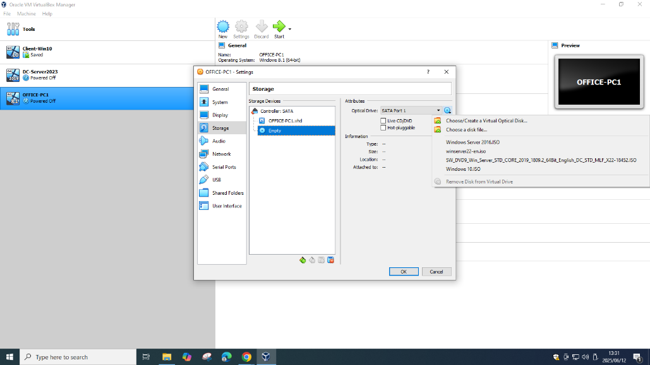

Step 6: Select Windows 8 ISO

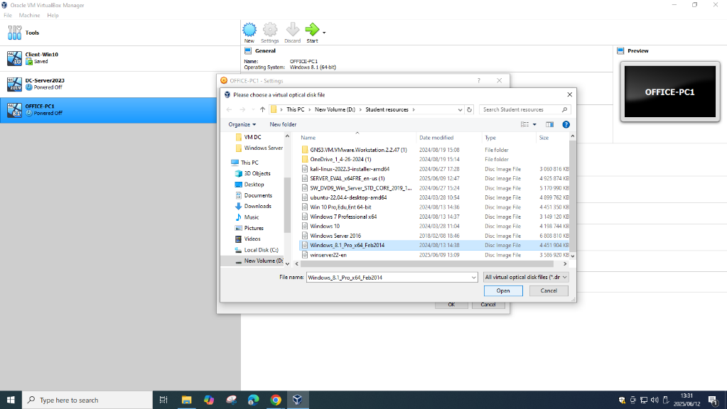

Step 7: Click OK

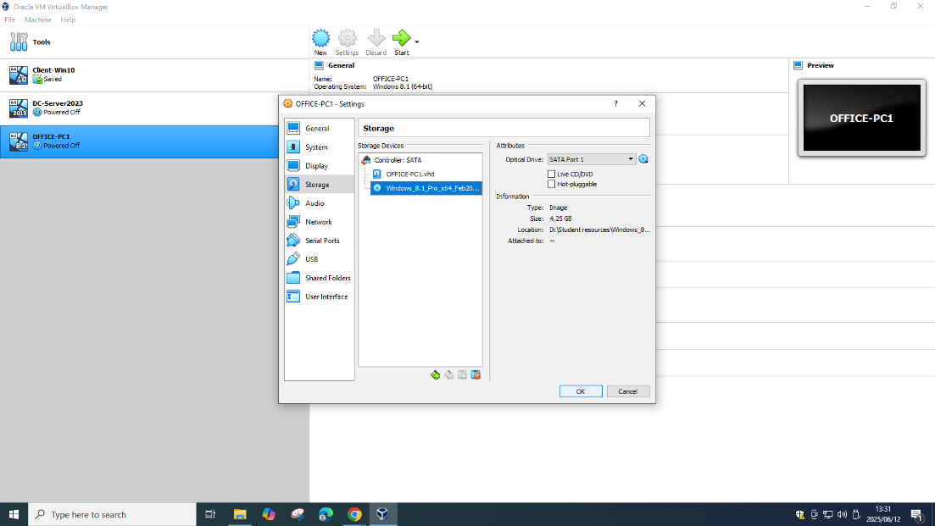

Step 8: Start the virtual machine, Click Next

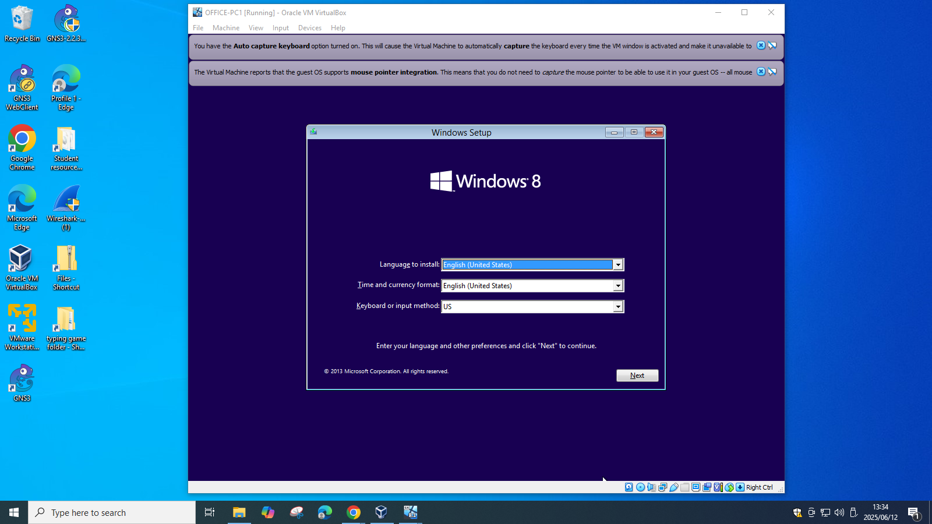

Step 9: Install Now

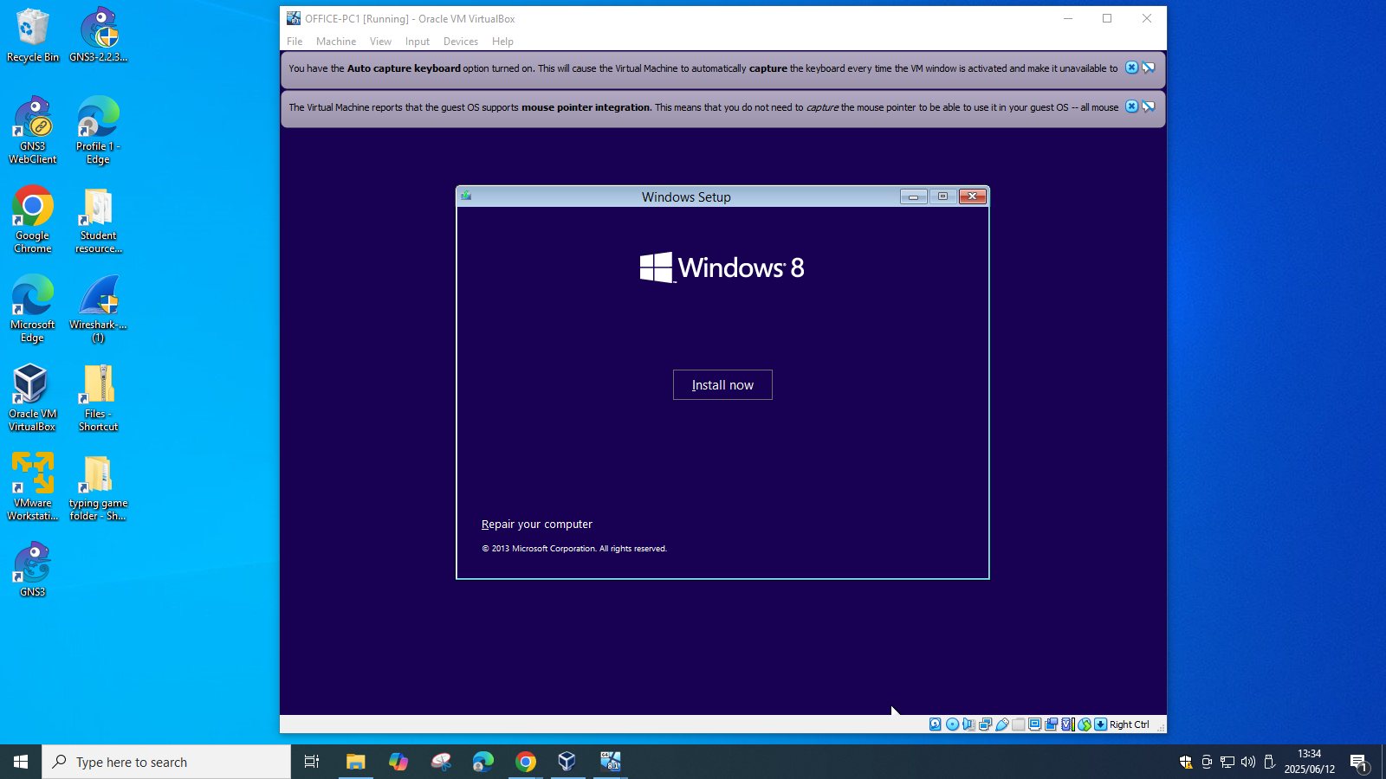

Step 10: Select Custom

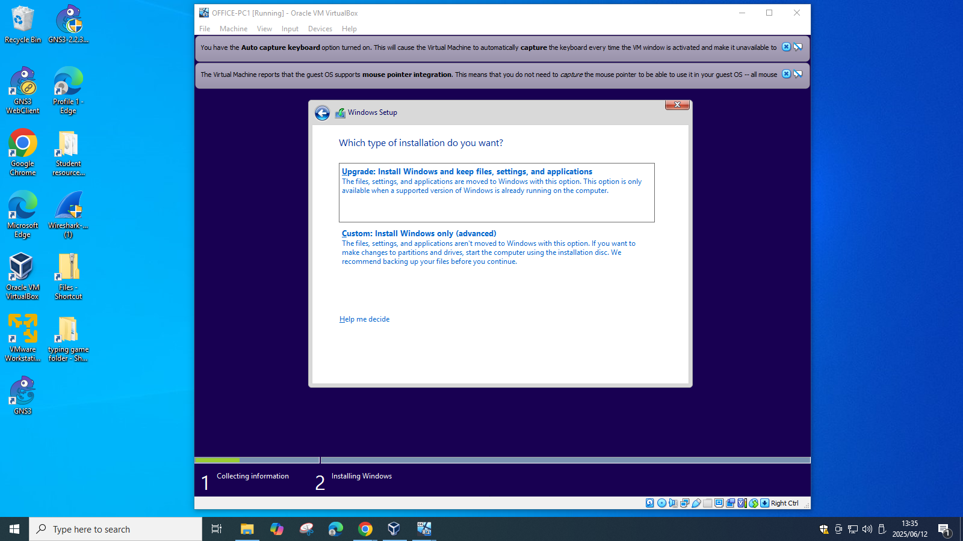

Step 11: Click Next

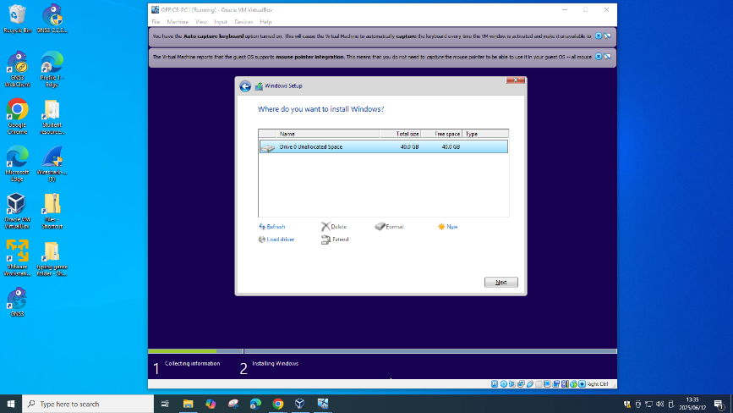

Step 12: Name OFFICE-PC1

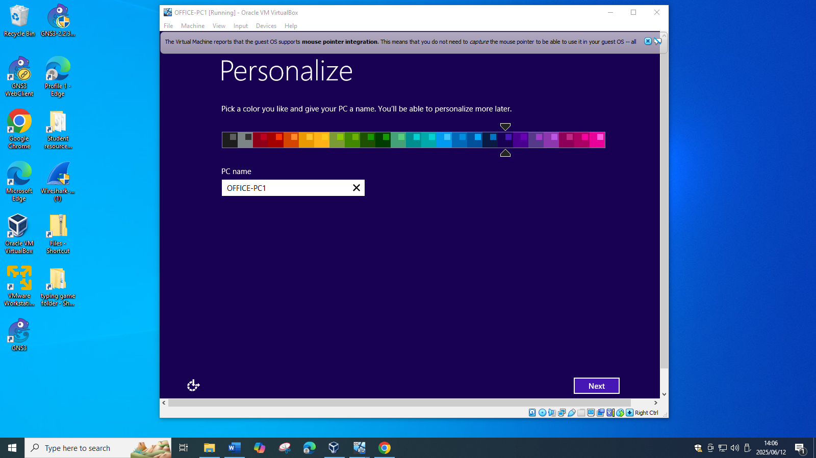

Step 13: Use Express Settings

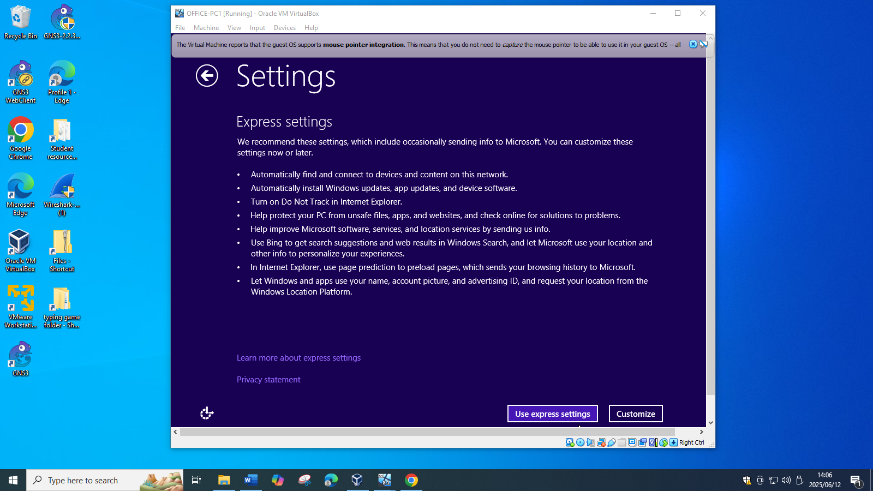

Step 14: User name and Password, Click Finish

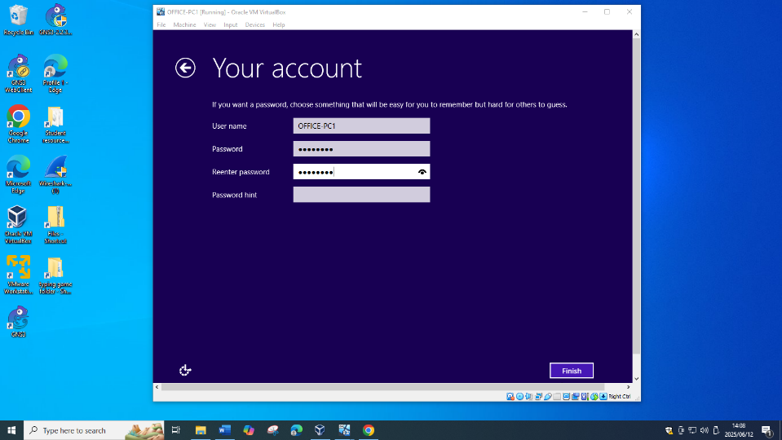

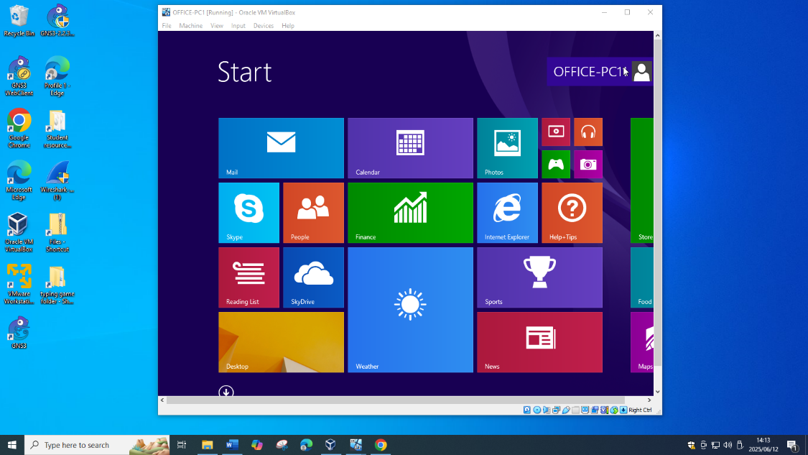

For VM 2

Step 1: Click on New, Name OFFICE PC-2, Type Microsoft Windows, Version Windows 10(32 or 64 bit based on your device), click Create

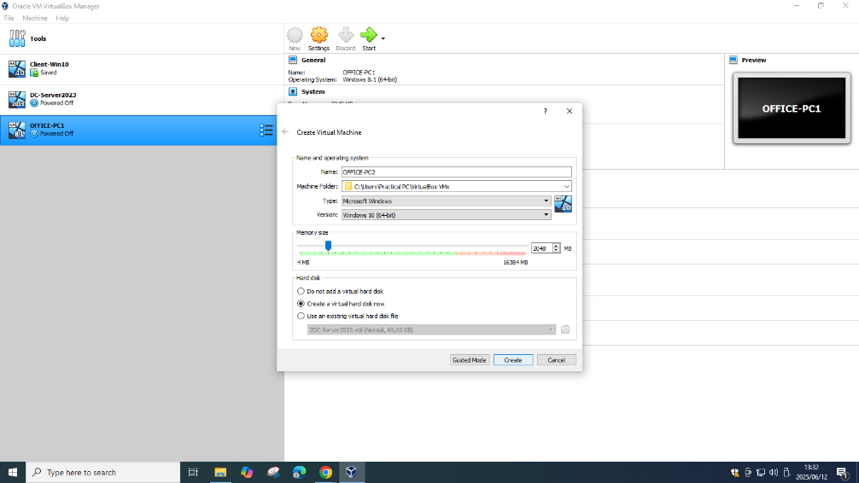

Step 2: Create VHD click Create

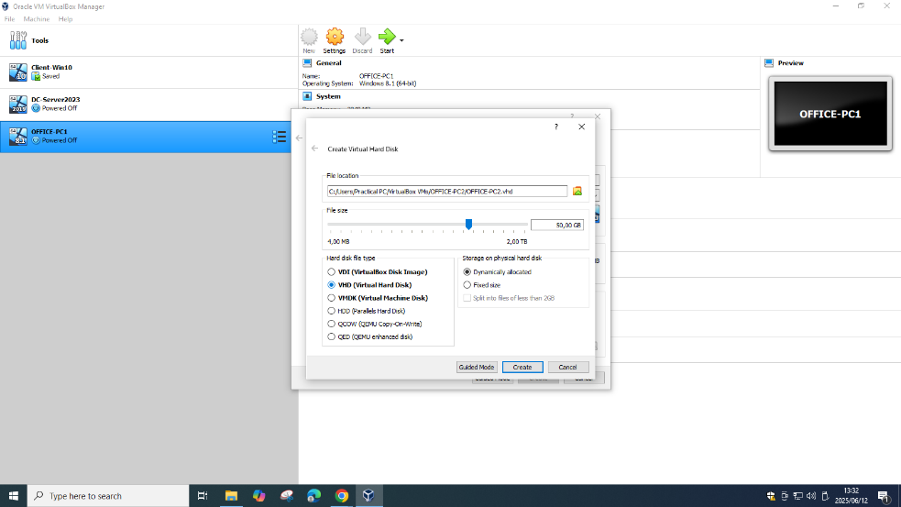

Step 3: Go to the Virtual machines settings, click on Storage, Click the Empty CD/DVD, Click the dropdown box on the right and Choose a disk file

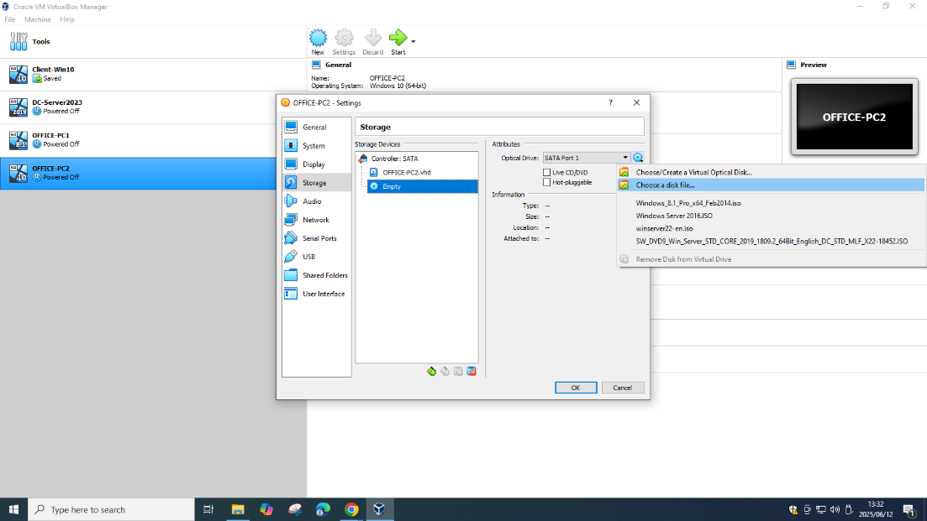

Step 4: Select Windows 10 and Open

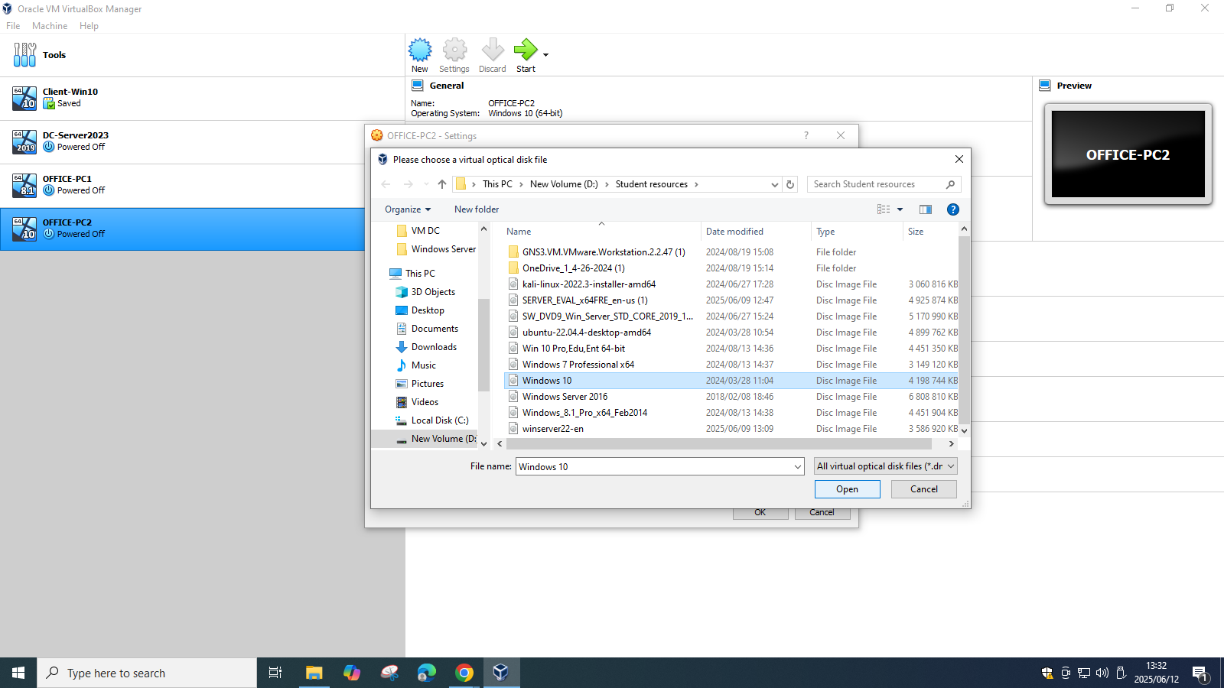

Step 5: Click Ok

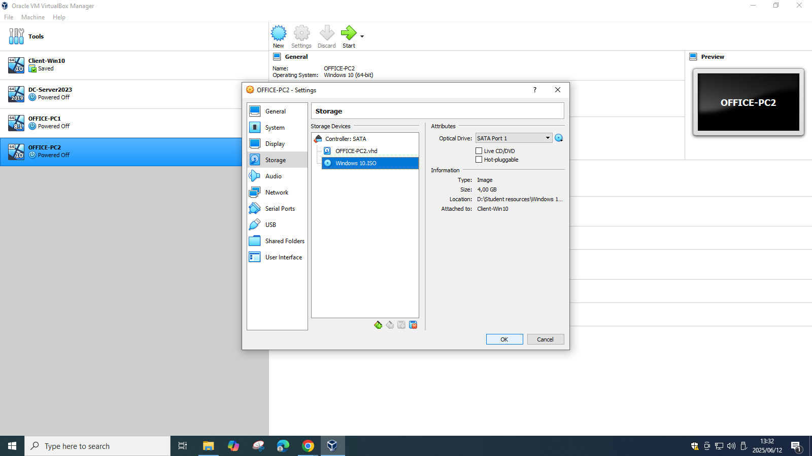

Step 6: Start the Virtual Machine, Click Next

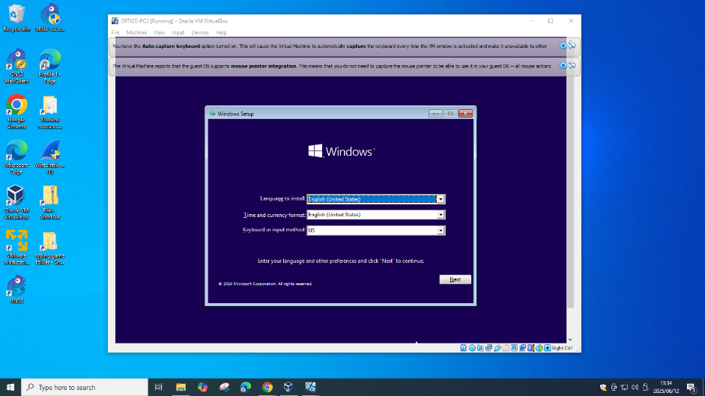

Step 7: Install Now

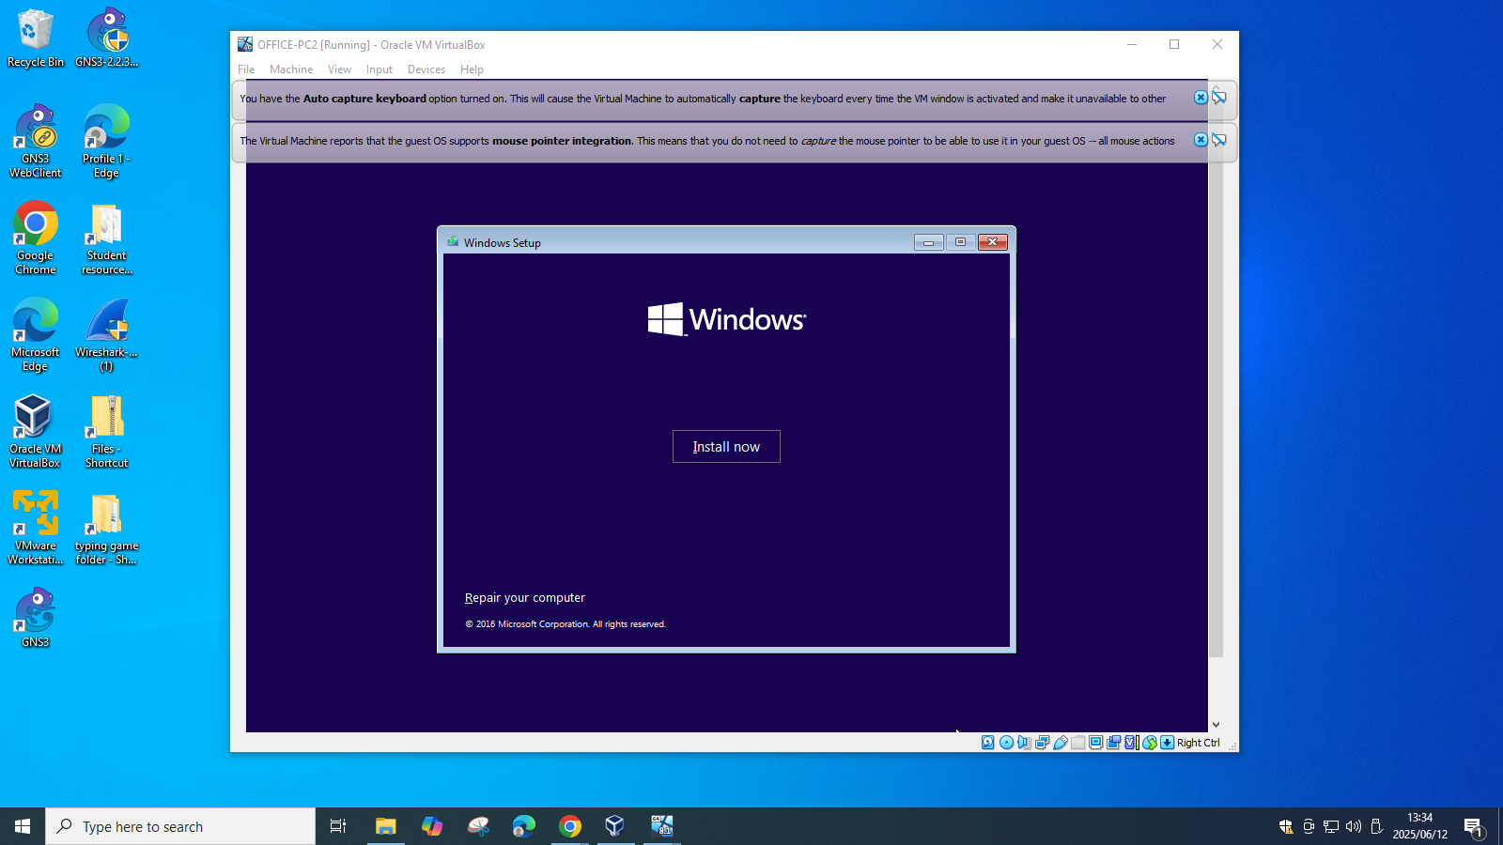

Step 8: Accept and Click Next

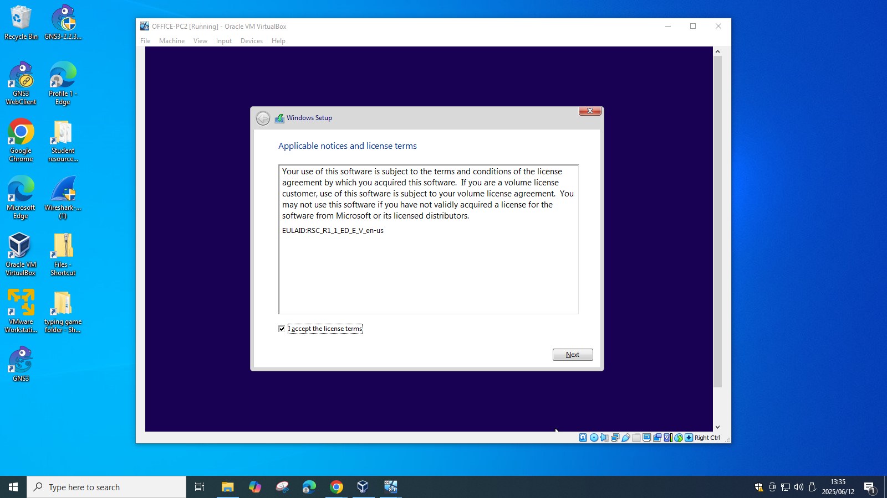

Step 9: Select Custom

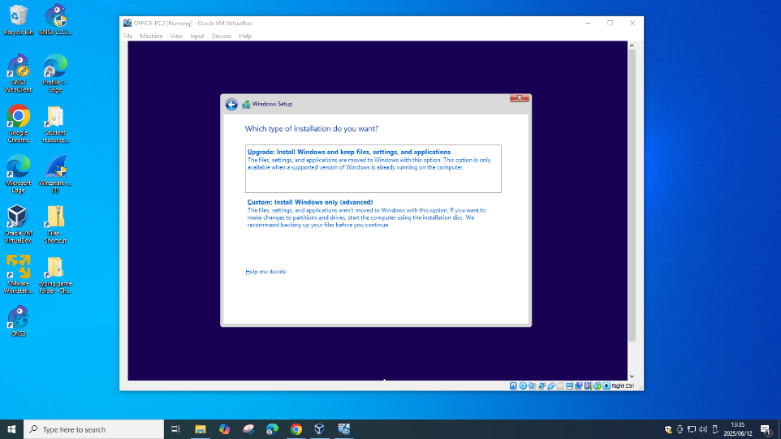

Step 10: Click Next

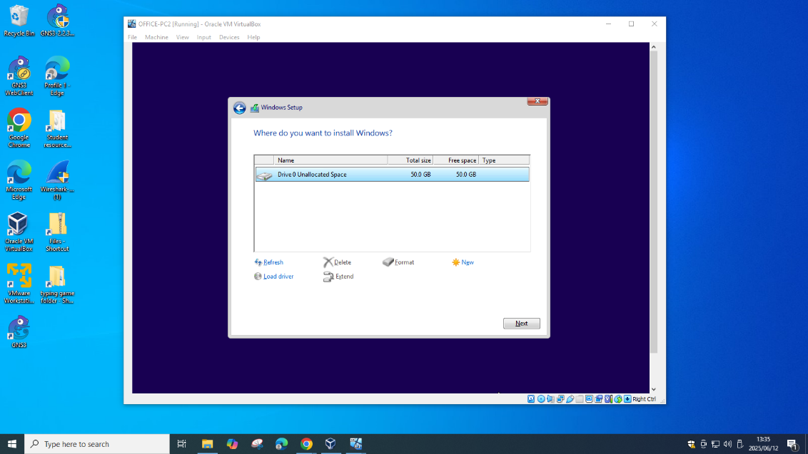

Step 11: Name and Password, Click Next

